Voting in a federal election
Polling place
A SOCIAL STORY

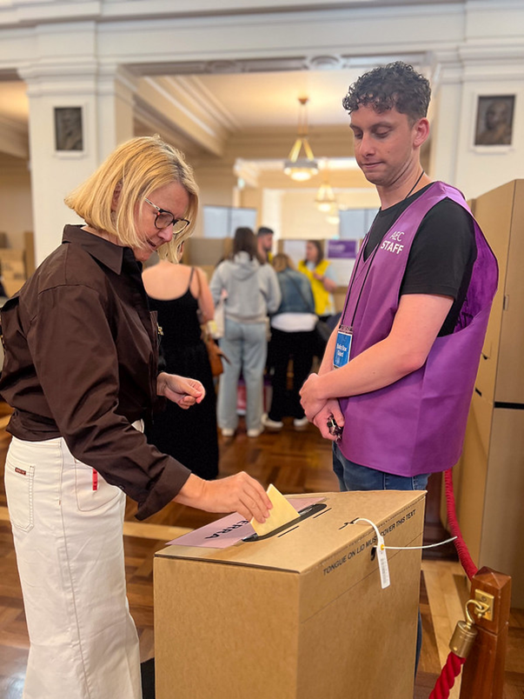
On election day, I will vote.
When I vote, I help to choose who is part of Australia’s government.
The government makes decisions on our behalf about how to run the country.
It’s important for me to have a say about who makes the decisions that affect me.
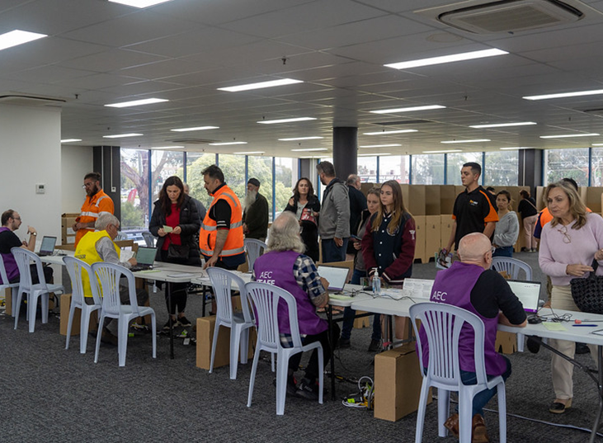

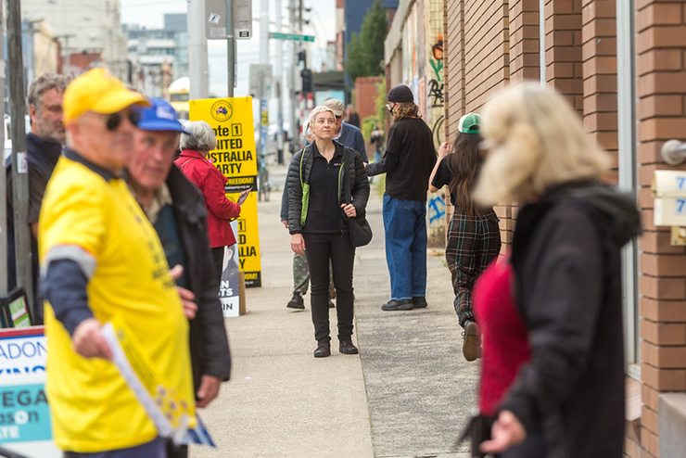

For me to make the best choice possible I can research the candidates or get advice from someone I trust.
My vote is secret. It’s my choice who I vote for, and I don’t need to tell anyone how I voted unless I want to.

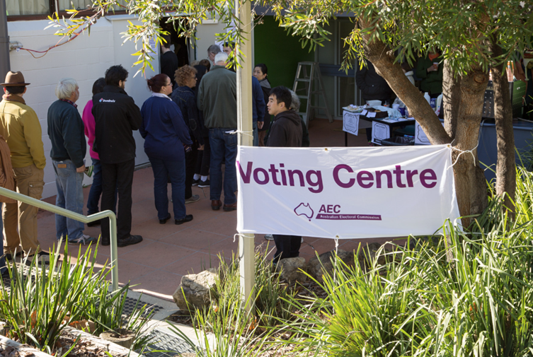

On election day, I will go to a polling place.
When I arrive at the polling place there might be a lot of people, and I might need to wait in a line.



It might be very noisy, and I might want to take ear plugs, headphones or a support person to help me.

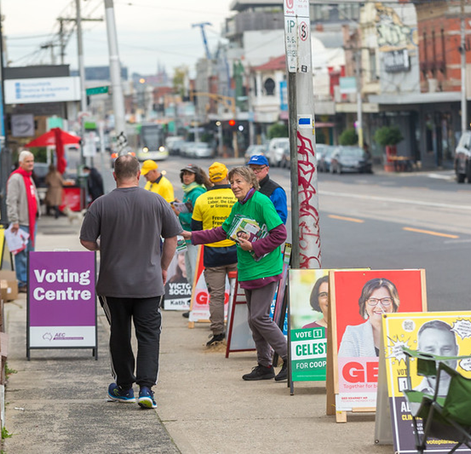
I might see people handing out pieces of paper. These pieces of paper explain how I might like to vote for a particular party.

I don’t have to take one if I don’t want to.

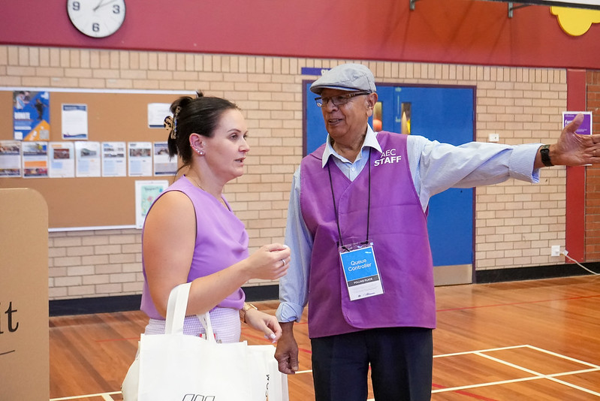
The Australian Electoral Commission, or AEC, is responsible for running the election.
When I go inside, I will speak to an AEC staff member in a purple vest with a lanyard around their neck. I can ask someone to help me at any time.

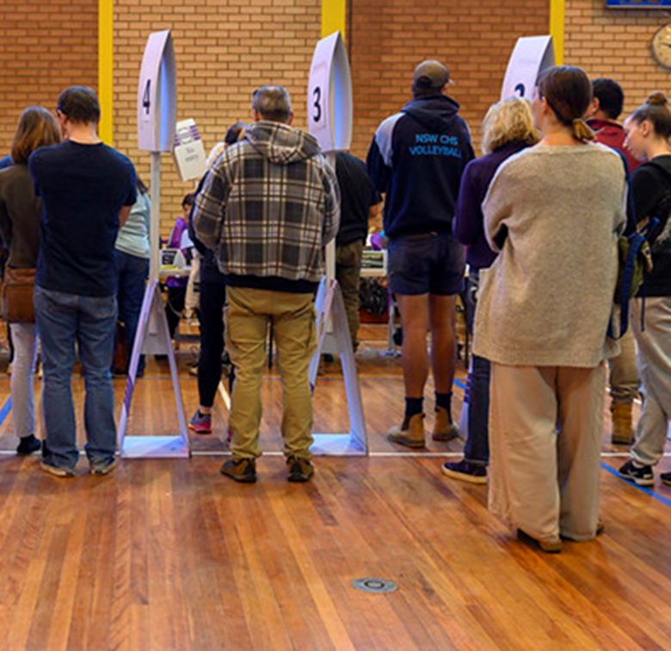

I might need to line up and wait for my turn before I get to vote.

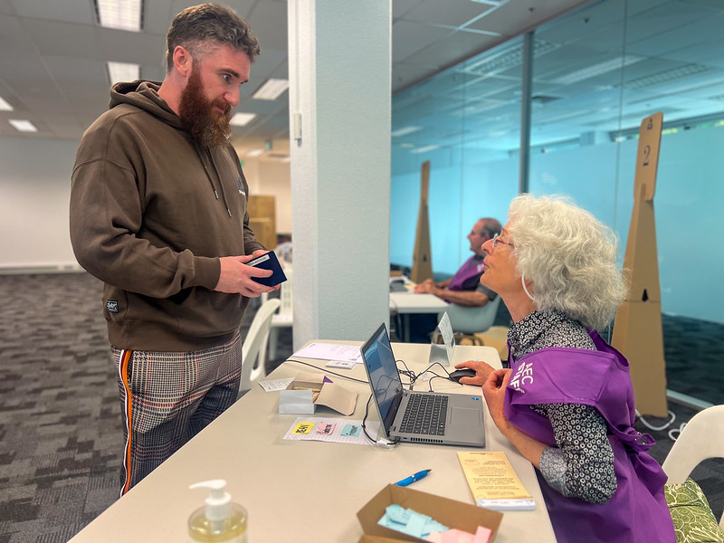

The staff member will help me find the table where I will speak to another AEC staff member.

This person will ask me 3 questions so they can find my name on the list.

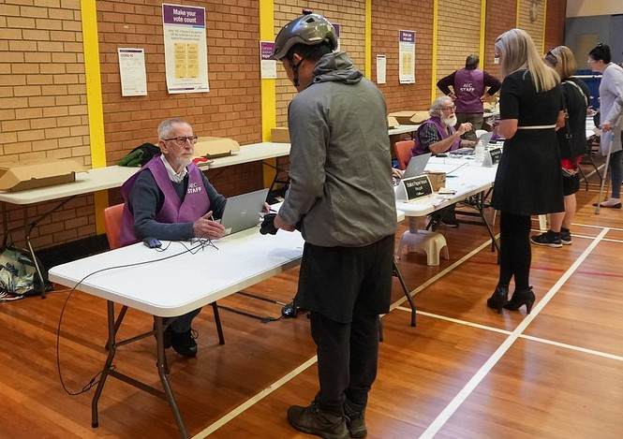

First, they will ask,
“What is your name?”
I need to tell them my first and last name.

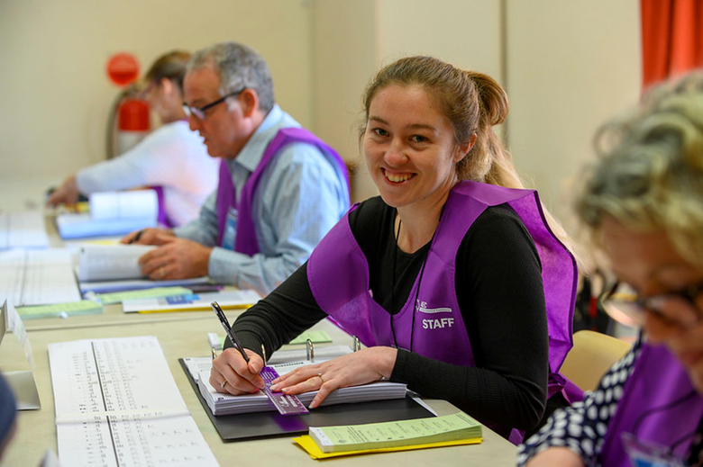

Next, they will ask,
“What is your address?”
I need to tell them the address I gave when I enrolled to vote. This address will probably be where I live.

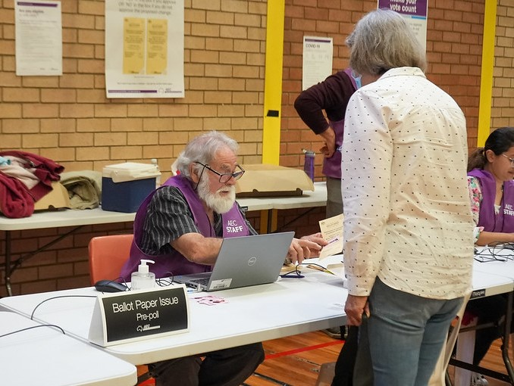

The third question they will ask is, “Have you voted before in this election?”
I need to say “No” if I haven’t voted in this election. I need to say “Yes” if I have already voted in this election.

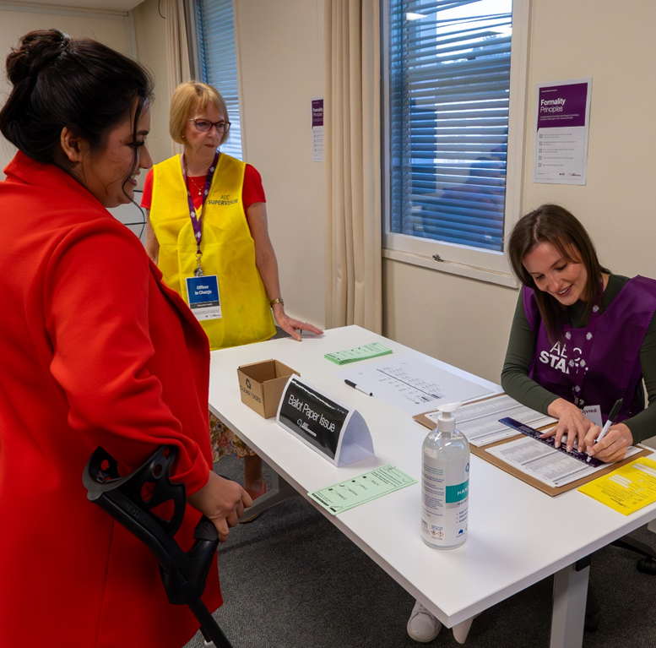

The AEC staff member will cross my name off the list.

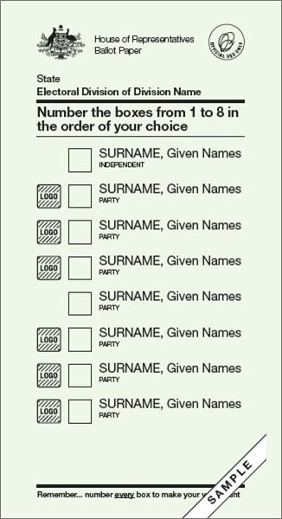

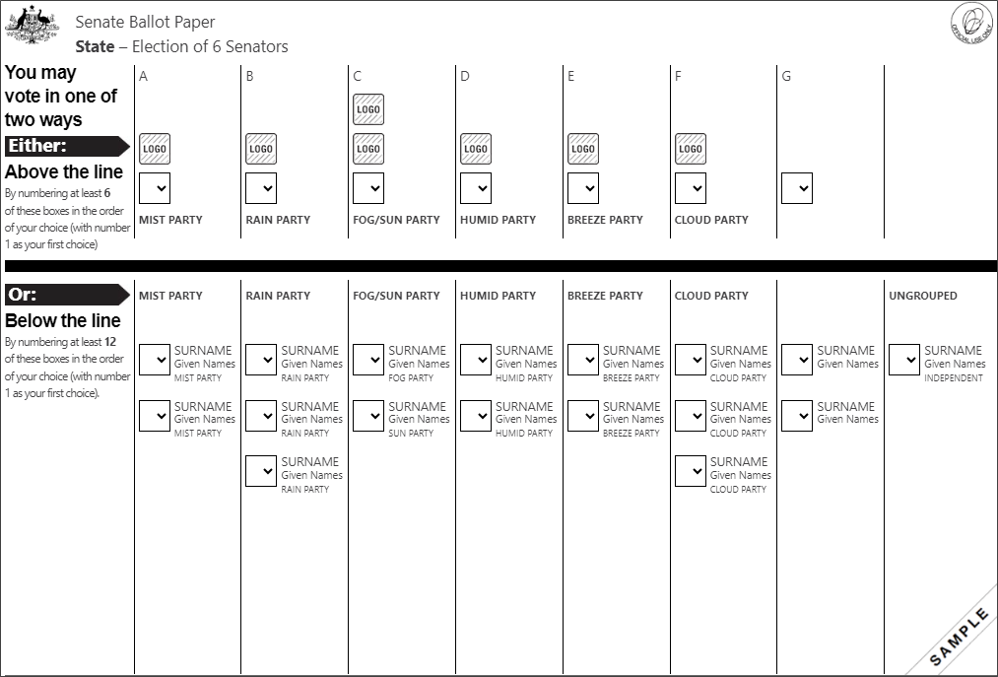

I will be given 2 ballot papers.

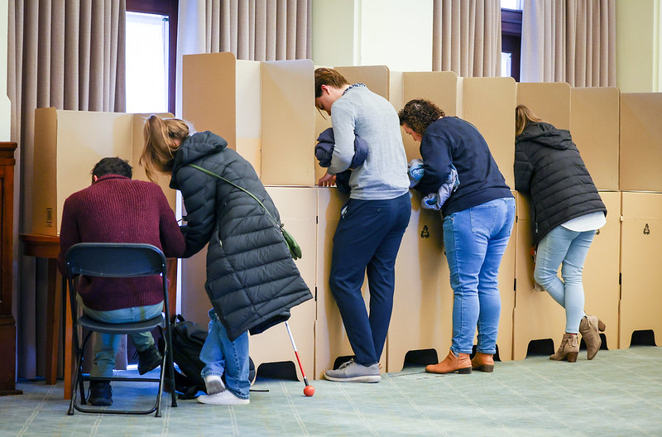
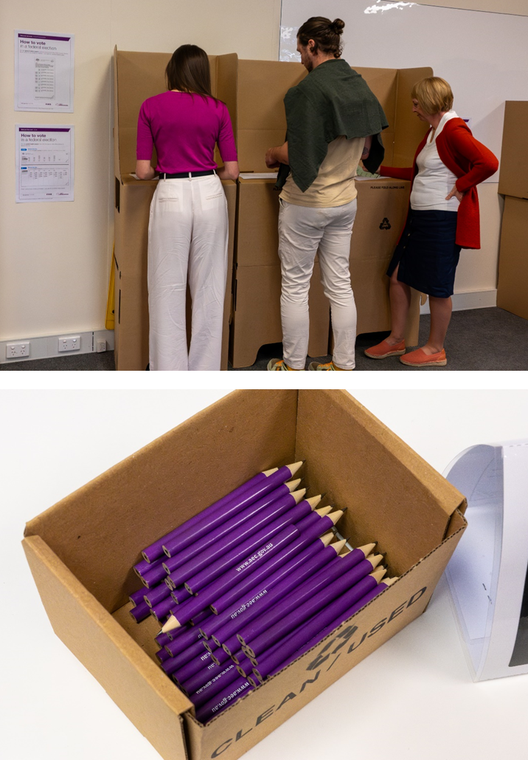
I need to take my ballot papers to the voting tables.
I will be given a pencil to fill out the ballot papers. I can also bring and use my own pen or pencil if I want to.

The green ballot paper is for the House of Representatives, and it has a list of all the candidates I can vote for.

A candidate is a person who wants to be part of the Parliament.

If the candidate belongs to a political party, it will be written under their name.
On the green ballot paper, I need to write 1 in the box next to my favourite candidate, then 2 in the box for my second favourite.
There are instructions on the ballot paper telling me how many numbers to write.
I need to keep writing numbers until all the boxes are filled.

The white ballot paper is for the Senate, and it has a list of all the candidates I can vote for.

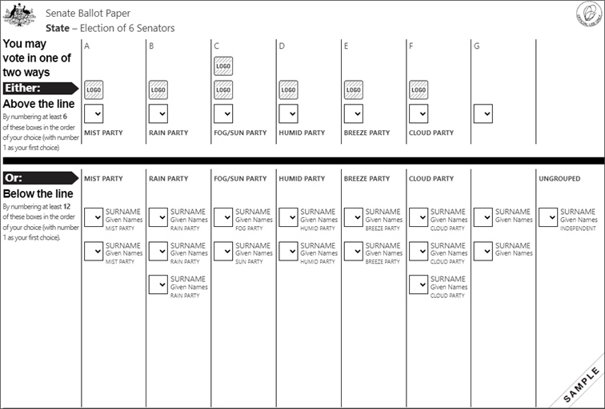
There is a list of groups above the black line.
Most of the groups are political parties.
A political party is a group of people who:
- share some of the same ideas
- work together on a plan for how government should run our country.
There is a list of candidates below the black line.
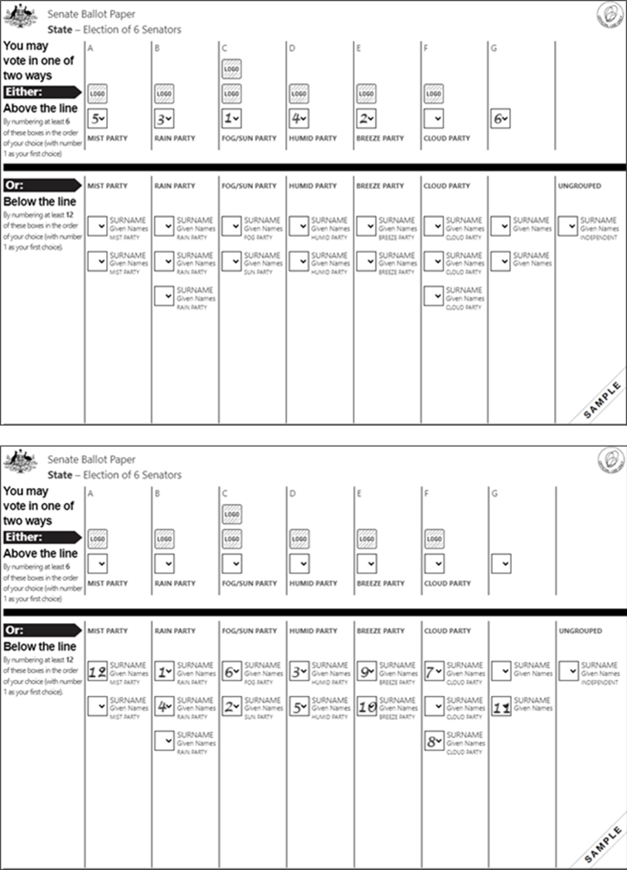

There are two ways I can vote. I get to choose.
I can vote above the line and vote for groups or political parties.
Or
I can vote below the line and vote for candidates.
I should read and follow the instructions on the ballot paper carefully to make sure my vote counts.

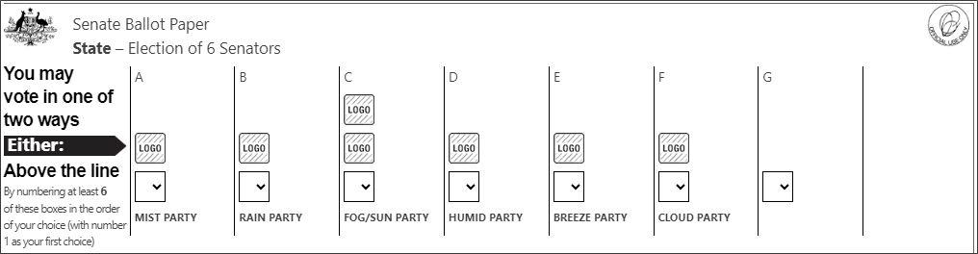
Write numbers 1–6
1 = my favourite
To vote above the line, I can put numbers in the boxes above the black line.
I will write a number 1 in the box for my favourite group, then 2 in the box for my second favourite.
I need to keep going until I have written numbers 1, 2, 3, 4, 5 and 6.
I can finish at 6 or keep going and write numbers in as many boxes above the line as I like.

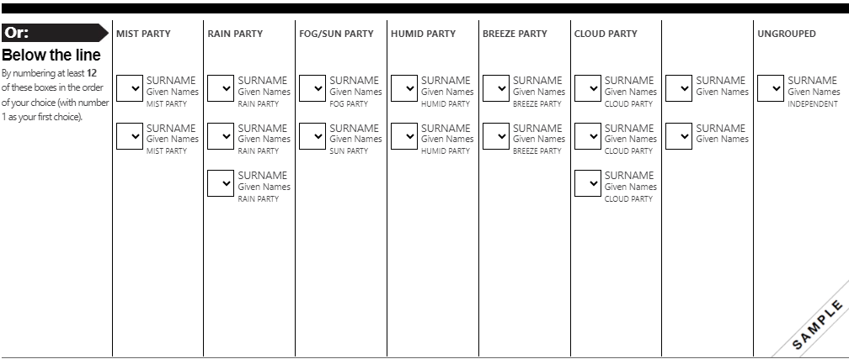
Write numbers 1–12
1 = my favourite
To vote below the line, I can put numbers in the boxes below the black line.
I will write 1 in the box next to my favourite candidate, then 2 in the box for my second favourite.
I need to keep going until I have written numbers 1 to 12.
I can finish at 12 or I can keep going and write numbers in as many boxes below the line as I like.
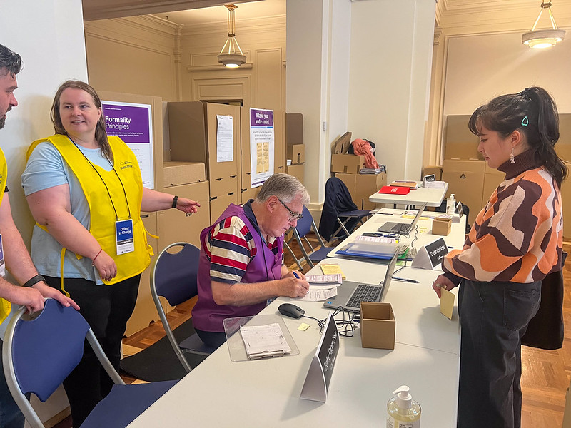
If I need help, I can ask one of the AEC staff or a friend or family member
If I make a mistake on my ballot papers, I can take them back to the AEC staff member who gave them to me.

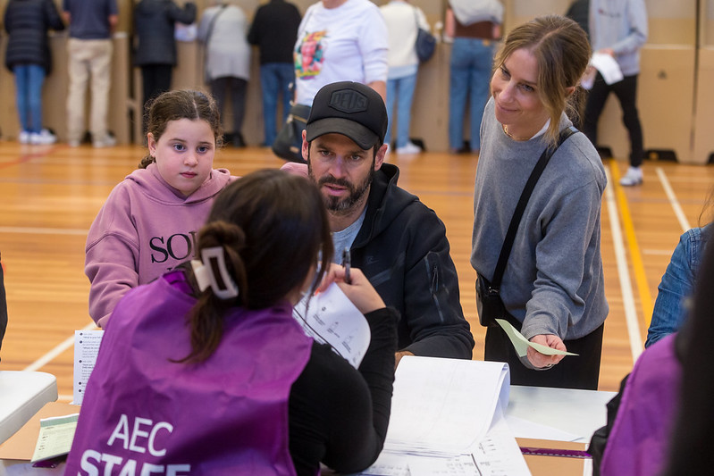

I can tell them I made a mistake and need a new ballot paper.
The AEC staff will:
- take the ballot paper with the mistake
- give me a new one
I will take the new ballot paper and fill it out.

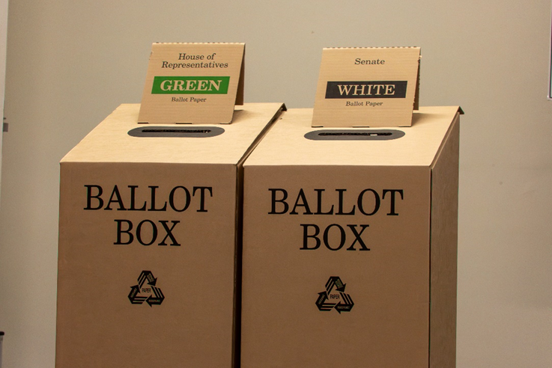

When I have voted I need to fold my ballot papers in half and put them in the ballot boxes.
There is one box for the green ballot paper and one box for the white ballot paper.

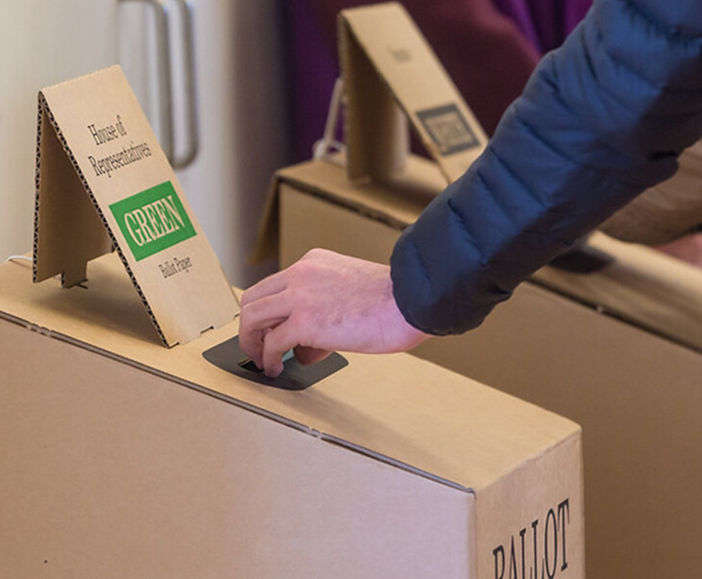

I will put my green ballot paper in the box that says: Green.
I will put my white ballot paper in the box that says: White.

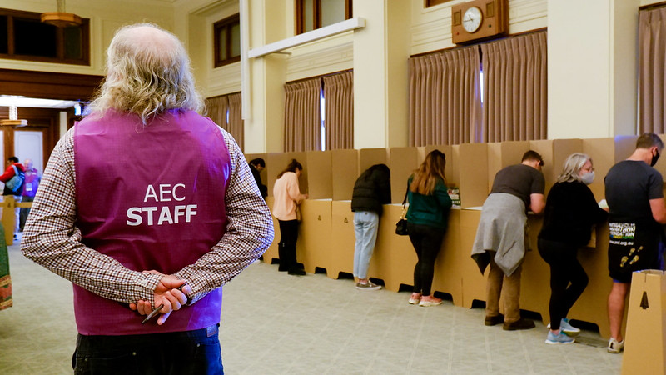

The AEC staff member can help show me which boxes to put my ballot papers in.

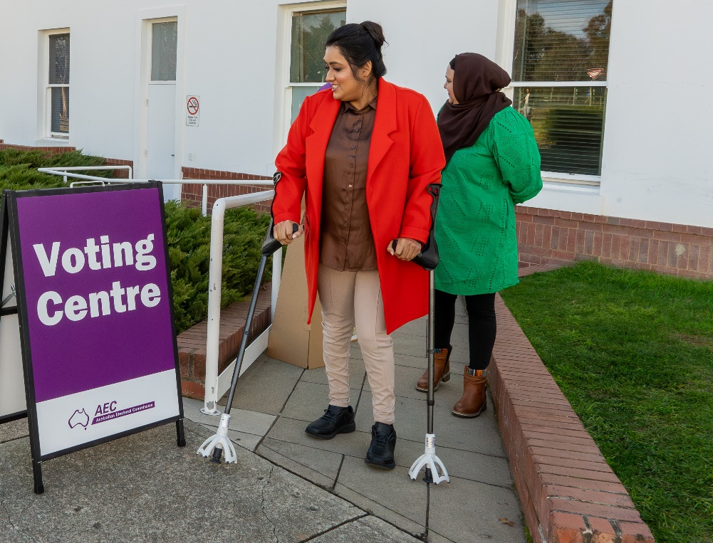

Now I have finished voting and I can leave.

